1. Dashaborad: <https://demo.milkride.com/admin/merchant/dashboard>

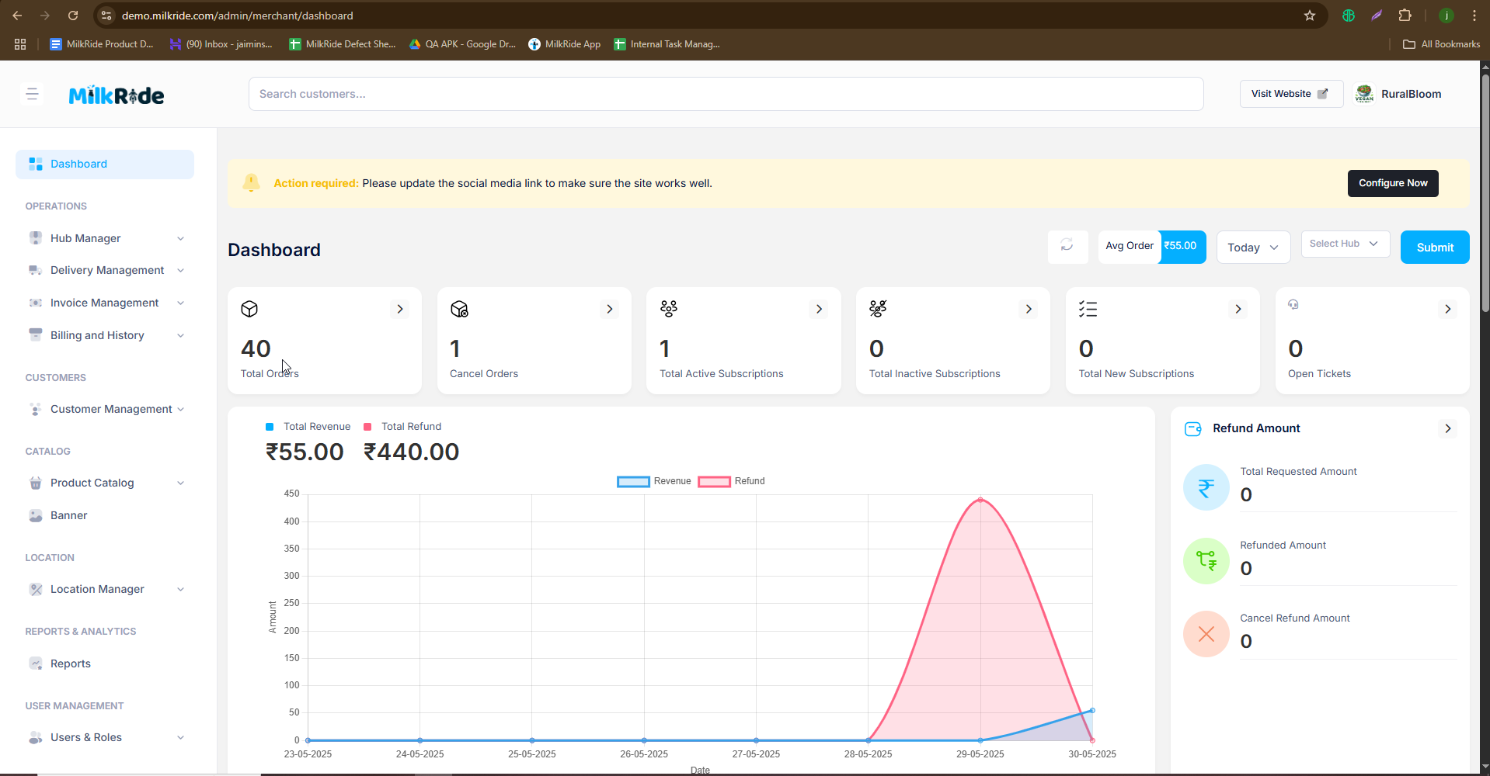

Oprations :

1. Hub Manager :

1.1 Hub list : https://demo.milkride.com/admin/hubs

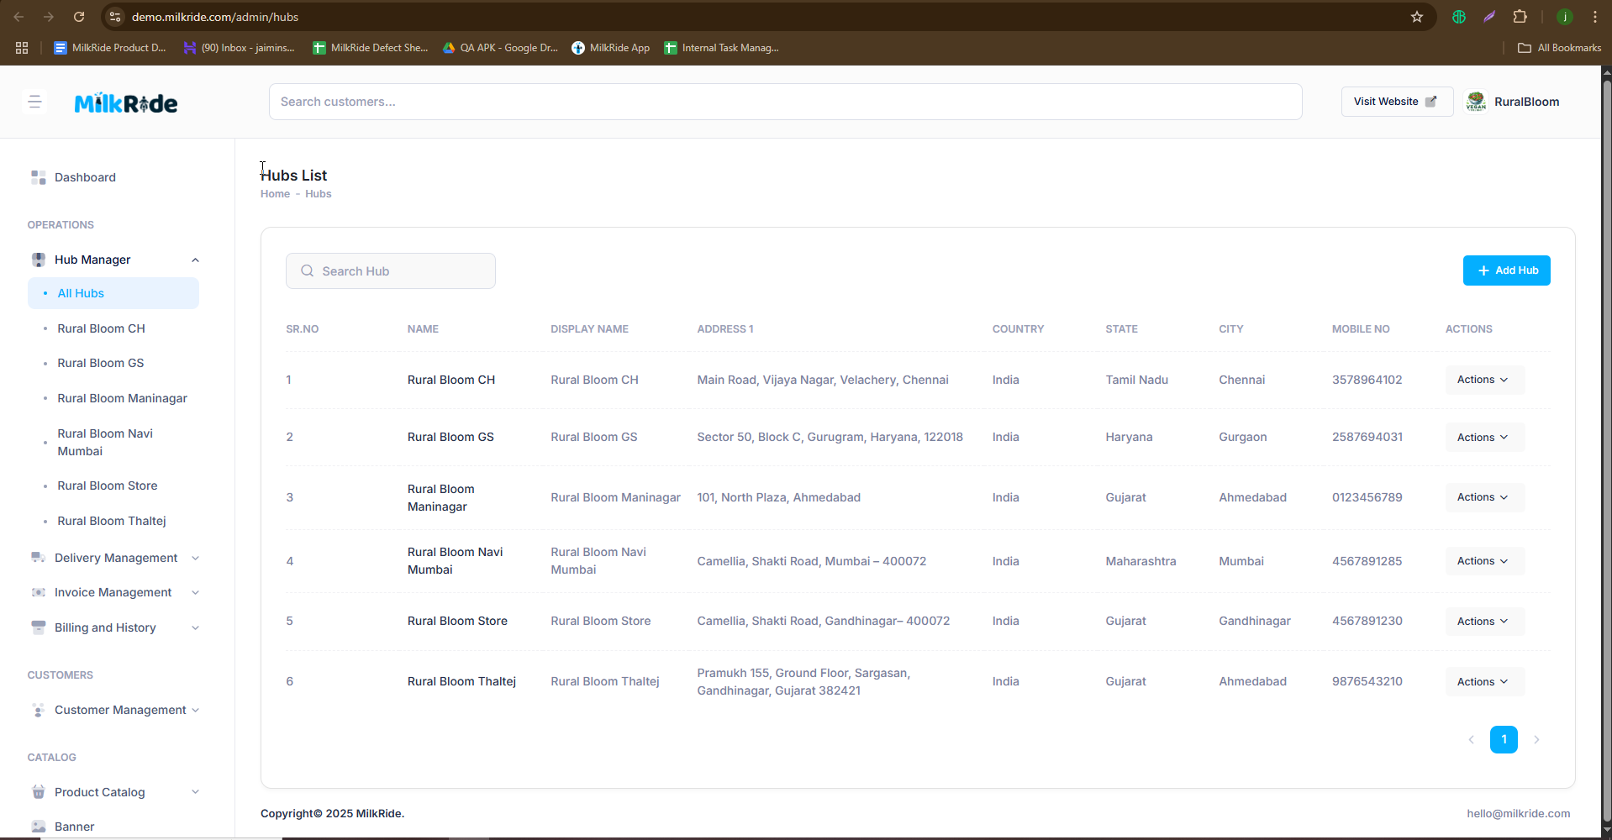

1.2 hub info : <https://demo.milkride.com/admin/hubs/show/20/info>

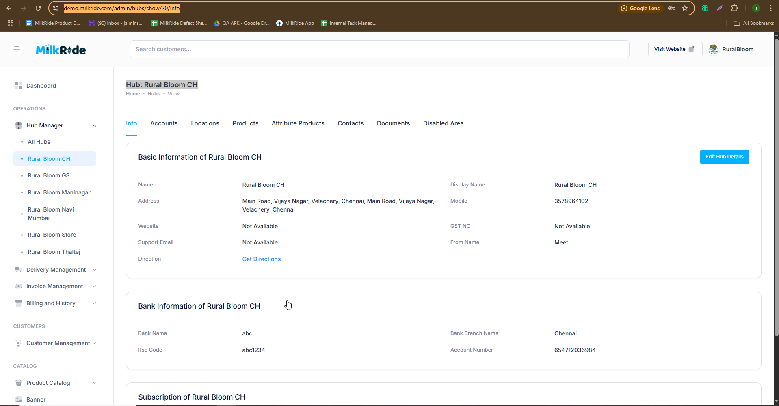

1.3 hub Account : https://demo.milkride.com/admin/hubs/show/20/users

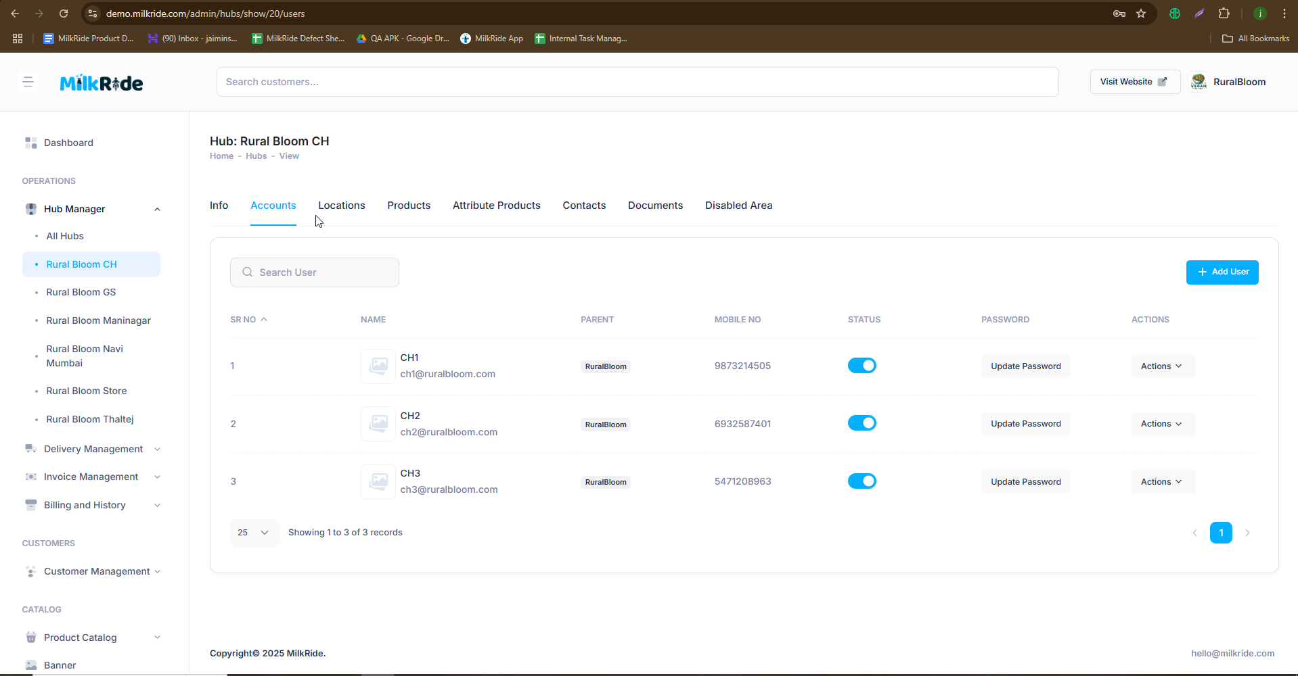

1.3 Hub location : <https://demo.milkride.com/admin/hubs/show/20/locations>

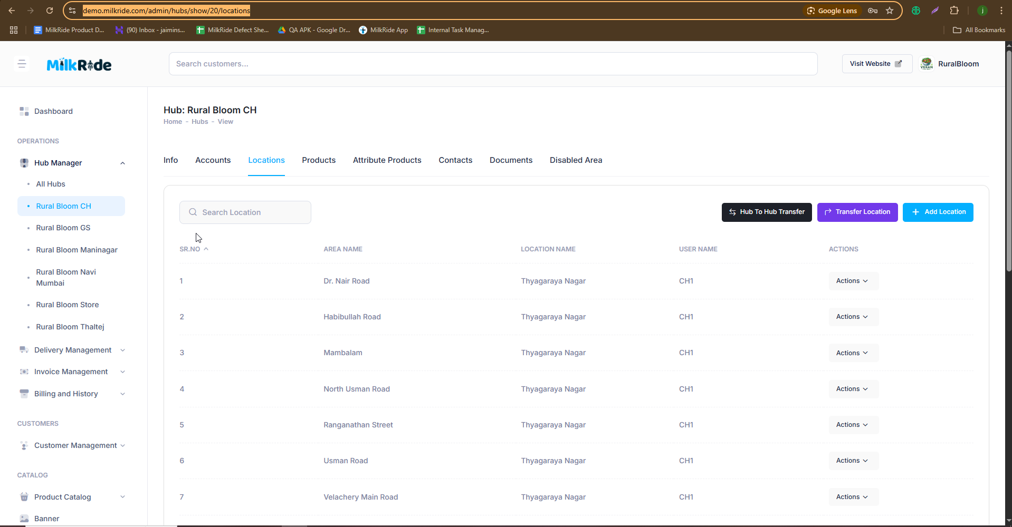

1.4 : hub product : <https://demo.milkride.com/admin/hubs/show/20/product_package>

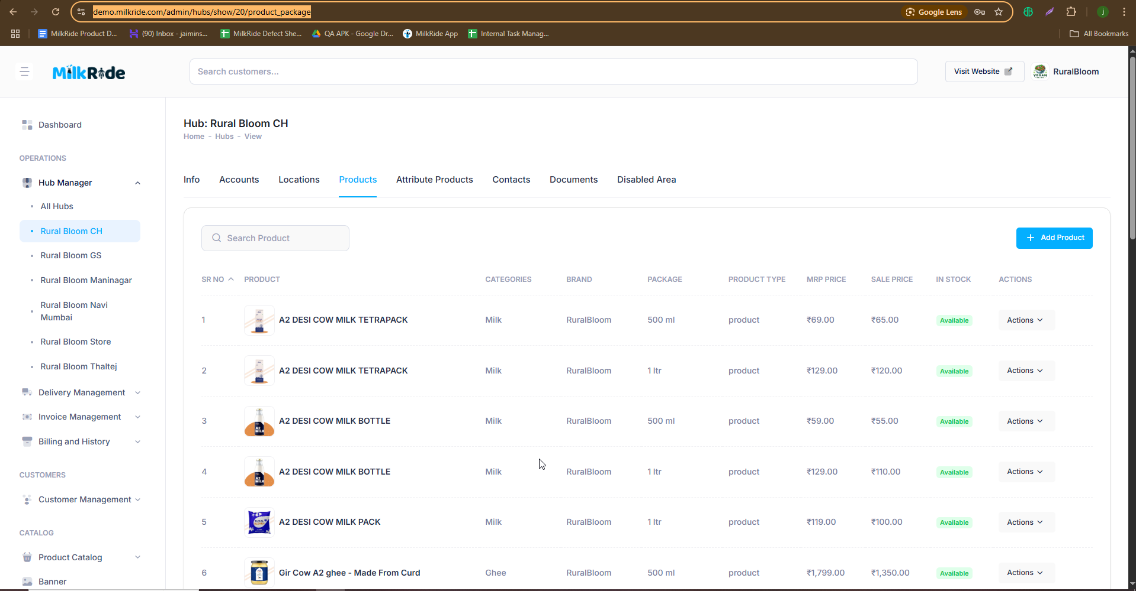

1.5 : hub attribute product : https: //demo.milkride.com/admin/hubs/show/20/attribute_packages

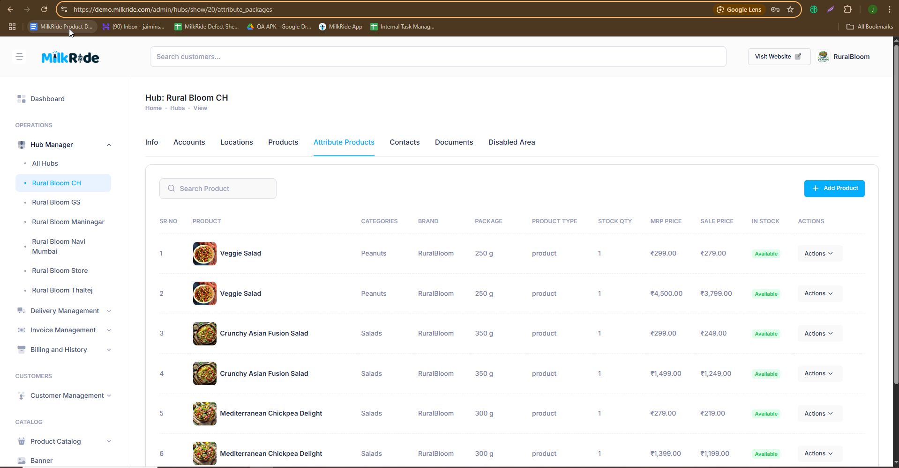

1.6 hub contacts : <https://demo.milkride.com/admin/hubs/show/20/contacts>

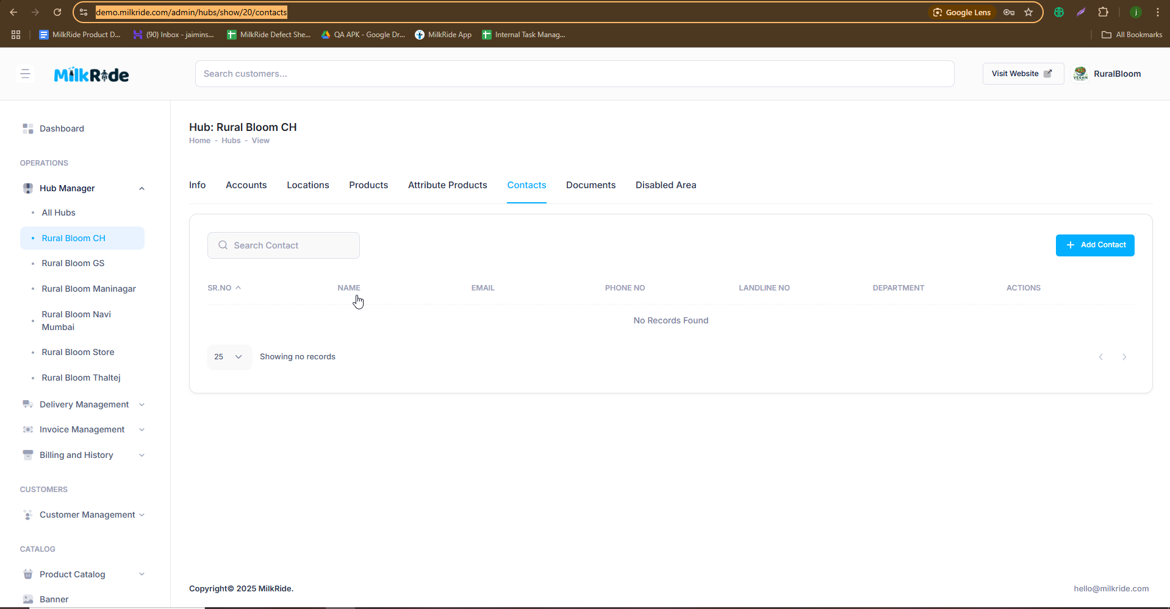

1.7 : hub doccument <https://demo.milkride.com/admin/hubs/show/20/documents>

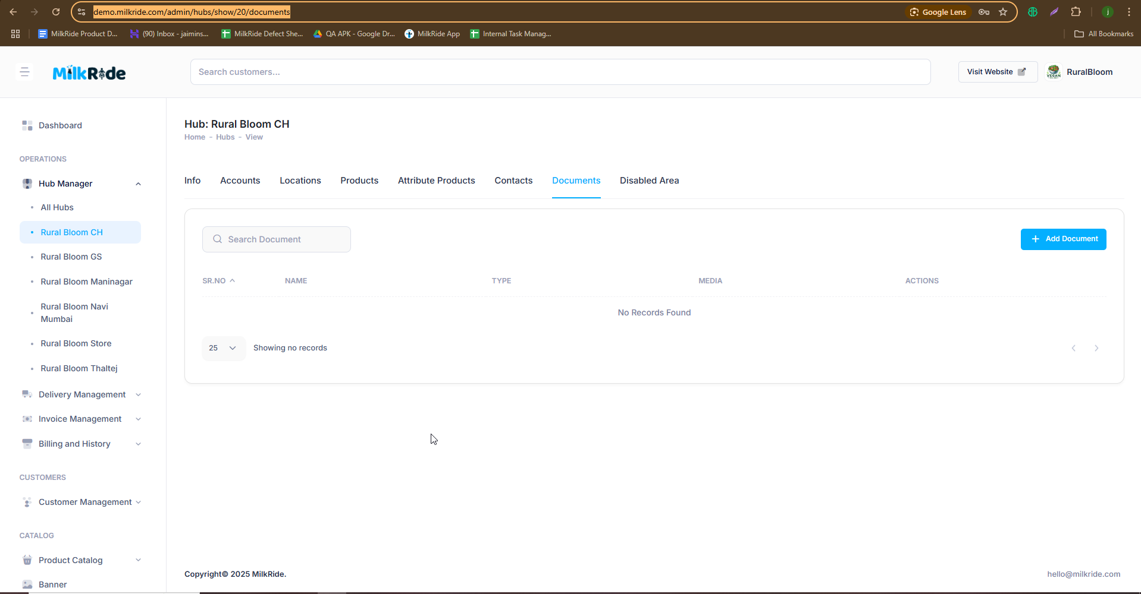

1.8 hub diable area : <https://demo.milkride.com/admin/hubs/show/20/disabled_area>

